Regularization
This is a form of regression, that constrains/ regularizes or shrinks the coefficient estimates towards zero. In other words, this technique discourages learning a more complex or flexible model, to avoid the risk of overfitting.
A simple relation for linear regression looks like this. Here Y represents the learned relation and β represents the coefficient estimates for different variables or predictors(X).
Y ≈ β0 + β1X1 + β2X2 + …+ βpXp
The fitting procedure involves a loss function, known as residual sum of squares or RSS. The coefficients are chosen, such that they minimize this loss function.
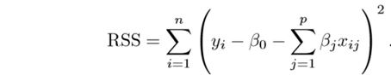
Now, this will adjust the coefficients based on your training data. If there is noise in the training data, then the estimated coefficients won’t generalize well to the future data. This is where regularization comes in and shrinks or regularizes these learned estimates towards zero.

Ridge Regression
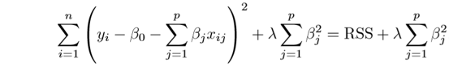
Above image shows ridge regression, where the RSS is modified by adding the shrinkage quantity. Now, the coefficients are estimated by minimizing this function. Here, λ is the tuning parameter that decides how much we want to penalize the flexibility of our model. The increase in flexibility of a model is represented by increase in its coefficients, and if we want to minimize the above function, then these coefficients need to be small. This is how the Ridge regression technique prevents coefficients from rising too high. Also, notice that we shrink the estimated association of each variable with the response, except the intercept β0, This intercept is a measure of the mean value of the response when xi1 = xi2 = …= xip = 0.

Lasso
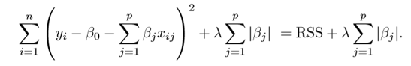
Lasso is another variation, in which the above function is minimized. Its clear that this variation differs from ridge regression only in penalizing the high coefficients. It uses |βj|(modulus)instead of squares of β, as its penalty. In statistics, this is known as the L1 norm.
Lets take a look at above methods with a different perspective. The ridge regression can be thought of as solving an equation, where summation of squares of coefficients is less than or equal to s. And the Lasso can be thought of as an equation where summation of modulus of coefficients is less than or equal to s. Here, s is a constant that exists for each value of shrinkage factor λ. These equations are also referred to as constraint functions.
Consider their are 2 parameters in a given problem. Then according to above formulation, the ridge regression is expressed by β1² + β2² ≤ s. This implies that ridge regression coefficients have the smallest RSS(loss function) for all points that lie within the circle given by β1² + β2² ≤ s.
Similarly, for lasso, the equation becomes,|β1|+|β2|≤ s. This implies that lasso coefficients have the smallest RSS(loss function) for all points that lie within the diamond given by |β1|+|β2|≤ s.
The image below describes these equations.
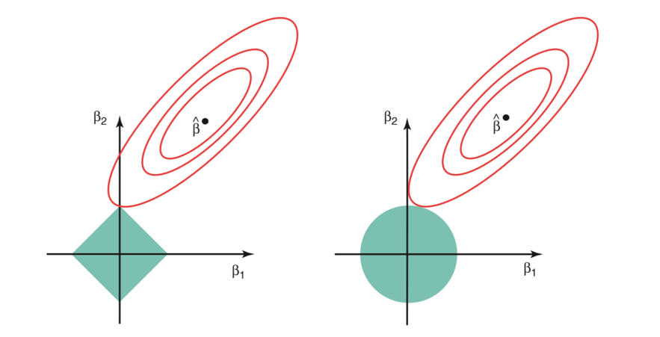
The above image shows the constraint functions(green areas), for lasso(left) and ridge regression(right), along with contours for RSS(red ellipse). Points on the ellipse share the value of RSS. For a very large value of s, the green regions will contain the center of the ellipse, making coefficient estimates of both regression techniques, equal to the least squares estimates. But, this is not the case in the above image. In this case, the lasso and ridge regression coefficient estimates are given by the ﬁrst point at which an ellipse contacts the constraint region. Since ridge regression has a circular constraint with no sharp points, this intersection will not generally occur on an axis, and so the ridge regression coeﬃcient estimates will be exclusively non-zero. However, the lasso constraint has corners at each of the axes, and so the ellipse will often intersect the constraint region at an axis. When this occurs, one of the coeﬃcients will equal zero. In higher dimensions(where parameters are much more than 2), many of the coeﬃcient estimates may equal zero simultaneously.
This sheds light on the obvious disadvantage of ridge regression, which is model interpretability. It will shrink the coefficients for least important predictors, very close to zero. But it will never make them exactly zero. In other words, the final model will include all predictors. However, in the case of the lasso, the L1 penalty has the eﬀect of forcing some of the coeﬃcient estimates to be exactly equal to zero when the tuning parameter λ is suﬃciently large. Therefore, the lasso method also performs variable selection and is said to yield sparse models.

What does Regularization achieve?
A standard least squares model tends to have some variance in it, i.e. this model won’t generalize well for a data set different than its training data. Regularization, significantly reduces the variance of the model, without substantial increase in its bias. So the tuning parameter λ, used in the regularization techniques described above, controls the impact on bias and variance. As the value of λ rises, it reduces the value of coefficients and thus reducing the variance. Till a point, this increase in λ is beneficial as it is only reducing the variance(hence avoiding overfitting), without loosing any important properties in the data. But after certain value, the model starts loosing important properties, giving rise to bias in the model and thus underfitting. Therefore, the value of λ should be carefully selected.
Understanding the Bias-Variance Tradeoff in Machine Learning: Examples and Solutions
Introduction
Machine learning models play a pivotal role in various applications, from predicting customer behavior to diagnosing diseases. However, building an effective model is not a straightforward task. One of the central challenges in machine learning is striking the right balance between bias and variance. In this comprehensive guide, we will explore the bias-variance tradeoff in detail, provide examples to illustrate these concepts, and offer practical solutions to address bias and variance issues.
Bias and Variance: Definitions and Implications
Before we dive into the tradeoff, let’s establish a solid understanding of bias and variance:
Bias (Underfitting)
Bias refers to the error due to overly simplistic assumptions in the learning algorithm. A model with high bias tends to underfit the data, meaning it oversimplifies the underlying patterns. This leads to poor predictive performance as the model cannot capture the complexity of the real-world problem.
Example of High Bias:
Suppose you are training a linear regression model to predict housing prices. If the model assumes that the relationship between the features (e.g., square footage, number of bedrooms) and the price is strictly linear, it may perform poorly when the true relationship is more complex.
Variance (Overfitting)
Variance, on the other hand, is the error due to excessive complexity in the learning algorithm. A model with high variance captures not only the underlying patterns but also the noise in the training data. This leads to poor generalization to unseen data.
Example of High Variance:
Imagine training a decision tree with a very deep structure on a dataset of handwritten digits. While the tree can fit the training data perfectly, it might perform poorly on new, unseen digits because it has essentially memorized the training examples, including their individual quirks.
Identifying Underfitting and Overfitting
Now that we understand bias and variance, let’s discuss how to recognize whether a model is underfitting or overfitting.
Underfitting
Underfitting occurs when a model is too simplistic to capture the underlying patterns in the data. You can identify underfitting by analyzing the model’s performance on both the training and test datasets:
- Training Set: A model with high bias will struggle to fit the training data, resulting in low training accuracy (e.g., 60%).
- Test Set: The same model will also perform poorly on the test set, leading to low test accuracy (e.g., 65%).
In summary, underfitting results in a model that fails to grasp even the fundamental relationships in the data.
Overfitting
Overfitting happens when a model is excessively complex, capturing not just the patterns but also the noise in the training data. Identifying overfitting is a bit more nuanced:
- Training Set: A model with high variance can fit the training data exceedingly well, achieving high training accuracy (e.g., 95%).
- Test Set: However, this model will perform significantly worse on the test set, exhibiting lower test accuracy (e.g., 75%).
In essence, an overfit model “memorizes” the training data but struggles to generalize to new, unseen data.

The Tradeoff: Balancing Bias and Variance
The bias-variance tradeoff is the delicate equilibrium between underfitting and overfitting. The goal is to find the optimal level of complexity that allows a model to generalize effectively to unseen data. This tradeoff is often visualized as a curve, known as the validation error curve:

